

**FACULTY ONBOARDING PLAN**

**Arps Hall**

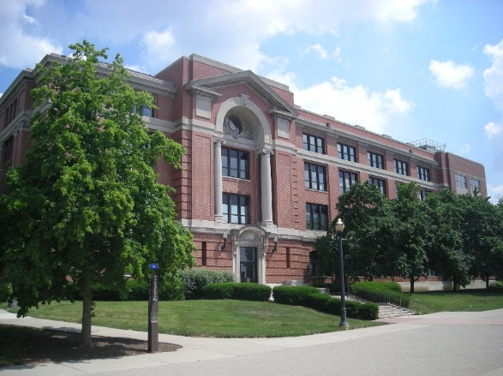

**NAME**

TITLE:

Email:

Employee ID:

Department:

Chair:

Dean:

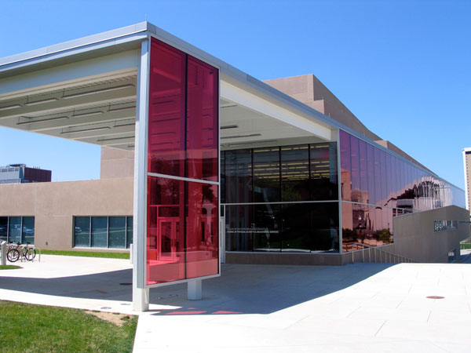 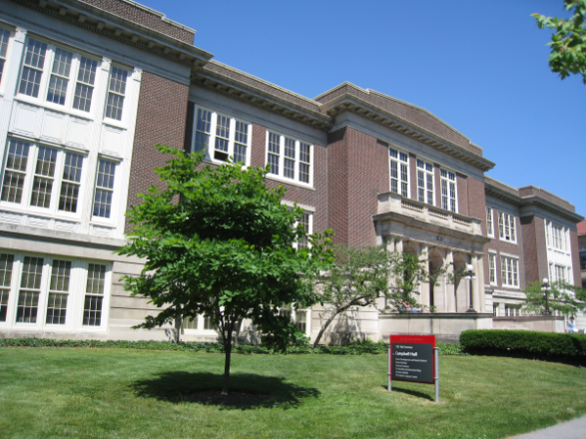

**Campbell Hall**

**PAES Building**



**Schoenbaum Family Center**

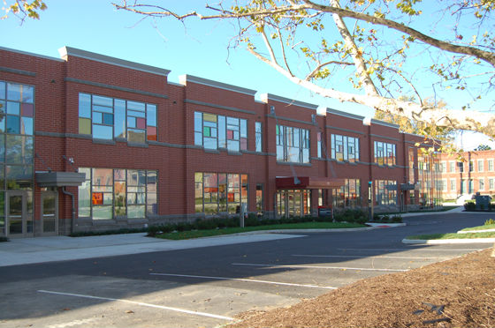

**Ramseyer Hall**

**CETE**

**Dennis Learning Center**

**Inside The Younkin Success Center**

In the College of Education and Human Ecology (EHE), our goal is to ensure that every new team member feels valued, equipped, and empowered to succeed in their role. This includes providing clear onboarding processes, access to resources, mentorship opportunities, and a culture that encourages collaboration, respect, and continuous learning. By investing in the success of our new colleagues, we strengthen our teams and create a workplace where everyone can thrive.

**What to expect after accepting your EHE Faculty position:**

|  |  |  |  |
| --- | --- | --- | --- |
| **Pre-Arrival** | **Name & Title** | **Schedule and Date** | **Completed “X”** |
| **Workday Onboarding Setup:** Is the completion of the Welcome Message that is sent to your Workday Inbox by your Chair.   |  |  |  |  | | --- | --- | --- | --- | | **Welcome to OSU** – You will receive a Welcome and Introductory email from the EHE HR Business Partner and Department HR Consultant.   * [OAA New Faculty Program](https://oaa.osu.edu/new-faculty-program) – The Office of Faculty Affairs (OAA) is eager to help you launch your teaching, research and services as a Buckeye. * [New Employee Onboarding](https://hr.osu.edu/new-employees/) – A guide for new employees and their managers to support a successful onboarding experience. |  |  |  | | **New Hire’s Chair/HRBP/HRC** | **Once Hire process is completed in Workday** |  |
| |  |  |  |  | | --- | --- | --- | --- | | **To prepare New Faculty for the first day –** The department should prepare the below and communicate it promptly to the New Faculty.   * Office Space Assignment and/or Remote Location (FWA) * Order Keys (Office and Building) * Order Door Nameplate * Order Business Cards * Confirm and Verify Computer and Printer Preferences * Office Set-up (Include Office Supplies) * Assign Mailbox and Copy Codes (If applicable) * Add to Dept. and EHE Listserv | **Department Executive Assistant** |  |  | | **New Faculty & Department Executive Assistant** | **Pre-Arrival** |  |
| **IT Request** - (*Brandon Smith, Chief Information Officer*)  EHE Office of Information Technology (OIT) will assist you with all your IT purchasing. This includes new equipment, replacement equipment, and software purchases.   * + [Order Computer and Printer](https://osu.teamdynamix.com/TDClient/3186/EHE/Home/) * Schedule IT Installation * EHE Computer Access * Phone (Headset/Receiver) SKYPE * Voicemail Set-up and User Instructions * Mobile Device connection instructions * Set up Duo | [**EHE IT Service Desk**](https://osuehe.teamdynamix.com/TDClient/1867/Portal/Requests/ServiceDet?ID=35583)  **New Faculty & Department Executive Assistant** | **Pre-Arrival** |  |
| **Relocation Allowance/Reimbursements**  This process is intended to support new hires with the relocation reimbursement process. For additional information to support your move or if you are interested in any of the below, email [relocation@osu.edu](mailto:relocation@osu.edu)   * [EHE Relocation Guidelines 2022.pdf](https://buckeyemailosu-my.sharepoint.com/:b:/g/personal/chambers_476_osu_edu/ERg8aMVUeTZDsOmAlNXKymwBug40vuD0wNjDTWtWw1bXQQ?e=sJeywo) EHE step by step process & instructions * The following [Relocation Expenses, 2.30 Policy](https://hr.osu.edu/wp-content/uploads/policy230.pdf) provides a full overview of eligible and ineligible relocation expenses. * [Moving Vendors, Area](https://hr.osu.edu/services/talent-acquisition/relocation-at-ohio-state/) Realtors, Temporary Housing, Housing in Columbus area, and Education in Columbus * Reach out to your [Department HR Consultant](https://portal.ehe.osu.edu/human-resources/ehe-hr-staff-and-workday-support) with any additional questions or assistance | [relocation@osu.edu](mailto:relocation@osu.edu) |  |  |
| **Obtain Buck ID, Parking Permit** (Items that you will need to obtain/complete please click on the below weblinks   * [Buck ID](https://buckid.osu.edu/) * [Parking Permit](https://osu.campusparc.com/home)   **\*\*\*Parking Pass:** You do not need to pay for the entire year at once, you are eligible for monthly payroll deductions**\*\*\*** | **New Faculty** |  |  |
| **EHE Office of Faculty Affairs -** *(Tasha Snyder, Associate Dean)*   * Introductions and Operation Overview * Promotion & Tenure Process * Register OAA New Faculty Orientation * Invitation to EHE Faculty Orientation | **Faculty Resource Coordinator** |  |  |
| **Office of Academic Affairs (OAA) –** This office has responsibility for the administration and coordination of all academic areas of the university. This includes curriculum, policy, and governance matters, academic misconduct, accreditation, regional campuses, and faculty support and development.  <https://oaa.osu.edu/> | **Visit Website for a wide range of Faculty Information** |  |  |
| **Upon Arrival** | **Name & Title** | **Scheduled and Date** | **Completed “X”** |
| **Department Chair**   * Overview of Department & Tour Facilities with Introductions to Colleagues * [EHE Core Values](https://ehe.osu.edu/about/) * [EHE Pillars](https://ehe.osu.edu/about/pillars-college) * [College Leadership](https://ehe.osu.edu/about/leadership) and Organizational Chart * Assign Faculty Mentor * Role, Responsibilities, and Expectations * Hours of Operation, Leave Guidelines, Internal Standards/Practices, etc. * Introduction to [EHE Portal](https://portal.ehe.osu.edu/) | **Chair & Executive Assistant Information** | **Date of Hire** |  |
| **Systems Trainings and Access –** In order to gain full access to the OSU systems there are required trainings that must be completed in [BuckeyeLearn](https://hr.osu.edu/news/tag/buckeyelearn/)   * + ***Institutional Data Policy*** – This course will describe your OSU role and responsibilities in preserving security and confidentiality while sharing and storing information. This training must be completed to gain access to OSU Systems.   + ***Report=Support! Identifying and Responding to Sexual Misconduct*** – How to identify, disrupt and report sexual misconduct. Must be Completed each year in order to be eligible for Annual Merit Increase | **New Faculty with HRC Support** |  |  |
| **Flexible Work Agreements (FWA) -** If working remotely and/or hybrid schedule, you and your Chair are required to complete a FWA using the date of hire as the begin date and 6/30 as the end date. (Dates can be edited as needed.)   * To complete your FWA to report your work location(s) click on the following link [Flexible Work Agreement](https://hr.osu.edu/policies/flexible-work/) (Information can also be found at HRconnection.osu.edu) | **Chair & New Faculty** |  |  |
| **Office of the Dean -** *(Don Pope-Davis, Dean)*   * Introductions and Operation Overview   **Chief of Staff & Director of Strategic Initiatives -** *(Nicole Luthy, Chief of Staff & Dir Strategic Operations)*   * Introductions and Operation Overview | **Melissa Newhouse, Sr. Executive Assistant**  Newhouse.37@osu.edu |  |  |
| **Office of Research Innovation ad Collaboration-ORIC -** *(Natasha Slesnick, Associate Dean of Research)*   * Introductions and Operation Overview   **Quantitative Methodology Center -***(Beverly Vandiver, Director)*   * Introductions and Operation Overview   **Qual Methods & EHE QualLab -***(Penny Pasque, Director)*   * Introductions and Operation Overview | **Matthew Eveland, ORIC Administrative Associate**  Eveland.19@osu.edu |  |  |
| **Engagement, Discovery and Global Education-EDGE -***(Noelle Arnold, Senior Associate Dean)*   * Introductions and Operation Overview | **Ryann Randall, Edge-Business Operations and Analyst**  Randall.140@osu.edu |  |  |
| **Office of Undergraduate Education**   * Introductions and Operation Overview |  |  |  |
| **EHE Finance & Business Office Meet and Greet -** *(Kelly Robinson Crawford, EHE Chief Administrative Officer)*   * Introductions and Operation Overview * Fiscal Department Structure within Unit and/or College * Role of the College and Departmental Financial Offices | **Dept Finance Officer** |  |  |
| **Human Resources Consultant Meet and Greet -***(Jackie Chambers, Human Resources Business Partner)*   * [HRconnection.osu.edu](https://hrconnection.osu.edu/esc) is used for general HR questions * <https://workday.osu.edu> * [Office of Human Resources website](https://hr.osu.edu/) * [Benefits information](https://hr.osu.edu/benefits/benefits-presentations/) Sign up to attend a ***Health and Retirement Benefits*** [Webinar](https://hr.osu.edu/benefits/benefits-presentations/) * [Your Plan for Health](https://yp4h.osu.edu/) | **Dept HR Consultant** | **Review Materials** |  |
| **Marketing and Communications -***(Stacey Dorr, Director)*   * As communications professionals for EHE, MarCom promotes faculty, staff, students, alumni and donors. * **Obtain Headshot** – Carol Delgrosso, Multimedia Specialist delgrosso.11@osu.edu * For additional information and resources <https://brand.ehe.osu.edu/> |  |  |  |
| **Instructional Design -***(Casey Rinehart, Director of Distance Education)*   * [We offer full course development](https://portal.ehe.osu.edu/service/academic-instructional-design-course-design) through group and 1-on-1 workshops, interactive learning objective production, activity and content brainstorming and development, EHE Canvas course templates, consultations, and workshops on teaching, learning, and educational technology. * Christy McLeod.53 – Human Sciences * Katie O’Keefe.89 – Teaching and Learning * Channell Walker.2680 – Ed Studies |  |  |  |
| **Staff Advisory Council** -*(Julie Miller, Co-Chair, & Ryan Provost, Co-Chair)*   * Introduction and Operation Overview of the [Staff Advisory Council](https://brand.ehe.osu.edu/) and/or the GA Process * Meet with member from the Staff Advisory Council to receive Welcome Letter * Miller.4325@osu.edu | **Julie Miller, Event Manager**  Miller.4325@osu.edu |  |  |
| **GA Manager -***(Amanda Crall, Graduate Associateship Manager)*   * Introduction and Operation Overview of GA Process * Amanda [Crall.25@osu.edu](mailto:Crall.25@osu.edu) | **Amanda Crall, Graduate Manager** Crall.25@osu.edu |  |  |
| **Manager Liaisons (ML):** Role – Initiates Workday transactions for Chairs and Faculty Managers on as as-needed basis for faculty with multiple direct reports. | **If applicable -will be Assigned** |  |  |
| **Additional Resources for New Hires and Faculty Managers** –   * [**Employee Orientation Companion Guide**](https://go.osu.edu/employee_orientation_companion_guide): Located in BuckeyeLearn, it provides guidance to help you support and engage your new staff member. * [**People Leader**](https://hr.osu.edu/new-employees/leaders/) **web page**: Provides additional resources specifically for roles that involve leading and managing non-student employees. If your new staff member will serve in a people leader capacity, both you and they may find this page especially helpful. * [Workday for Managers & Leaders -](https://admin.resources.osu.edu/workday/workday-for-managers-and-leaders/time-tracking-overview?check_logged_in=1) Review the learning resources below for assistance using Workday to perform managerial tasks like creating job requisitions, managing employee absences, and reviewing funding overrides. * [Policies and Forms](https://policies.osu.edu/) - This website provides convenient access to policies that apply across all of Ohio State * [Time Tracking Overview](https://admin.resources.osu.edu/workday/workday-for-managers-and-leaders/time-tracking-overview?check_logged_in=1) - University managers are responsible for approving, correcting, and otherwise managing their hourly employees' timesheets in Workday. * [Hiring for Managers and Leaders](https://admin.resources.osu.edu/workday/workday-for-managers-and-leaders/hiring-for-managers-and-leaders) - Hiring is a complex process that includes many different areas of the university, no matter where the employee works. This overview page is for hiring managers at both the university and Health System. * [BuckeyeLearn for Managers](https://admin.resources.osu.edu/buckeyelearn/buckeyelearn-for-managers) - Topics include: reviewing employee transcripts, assigning training, and reporting on employee training * [Performance Improvement](https://hr.osu.edu/services/elr/performance-improvement-corrective-action/) – Primary goal of corrective action is to facilitate performance and behavior improvement, rather than to serve as a punitive action. * [Safe and Healthy](https://safeandhealthy.osu.edu/) – Information on safe and healthy protocols from the University * [Pay Period and Holiday Schedule](https://busfin.osu.edu/buy-schedule-travel/payroll/paydate-schedule) – Information to give to staff regarding pay dates and holiday schedule. * [Career Roadmap](https://hr.osu.edu/career-roadmap/) - comprehensive job family model and pay structure that will provide visibility to career paths for managers and staff to foster equitable, consistent compensation practices across the university and medical center. * [Help Resources](https://hr.osu.edu/help/) – information to support managers trainings and other employees seeking help * [Manager Foundations](https://ohiostate.csod.com/ui/lms-learning-details/app/course/1b3989fb-adb5-4651-85d5-9901325265d6)- This training will build your foundation and confidence in using administrative technology that assists you in performing your work, managing employees, and leading people. Topics such as HR Connection, Workday, Microsoft 365, BuckeyeLearn, and others will be covered. * [Administrative Resource Center](https://admin.resources.osu.edu/) provides guides, job aids, training and more for current users of Ohio State's IT administrative tools. * [EHE faculty and staff portal](https://portal.ehe.osu.edu/) is the informational hub for the college - where you can find office sites and your contacts for services, where you can submit tickets for marketing and communications and IT support, and resources to support your important work here at EHE. |  |  |  |
| **Additional OSU Resources:**   * [Academic Calendar](https://registrar.osu.edu/staff/bigcal.asp) * [Classroom Scheduling](https://registrar.osu.edu/scheduling/index.asp) * [Campus Map](https://www.osu.edu/map/view) * [Carmen Canvas](https://carmen.osu.edu/) * Get to know the city of [Columbus](https://www.columbus.gov/) |  |  |  |

Once this Onboarding Plan is completed, return it to your Department HR Consultant who will send it via DocuSign for signatures and filed in your personnel file.

**______________________________ ________________**

**Faculty Signature Date**

**________________________________ _________________**

**Chair Signature Date**