**Graduate Education**

1945 N. High St., Arps Hall

Columbus, OH 43210

**GRADUATE STUDENT ONBOARDING PLAN**

**Arps Hall**

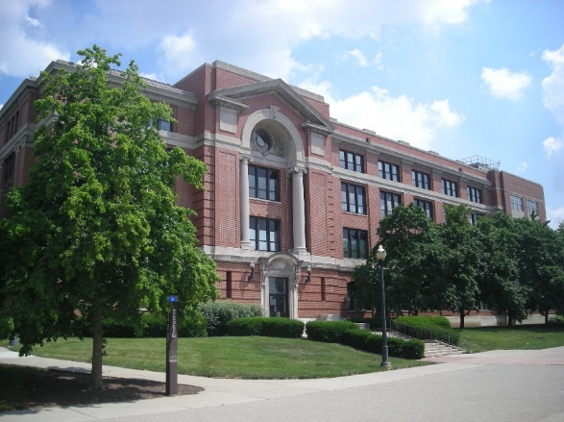

**NAME**

Title:

Email:

Employee ID:

Department:

Manager:

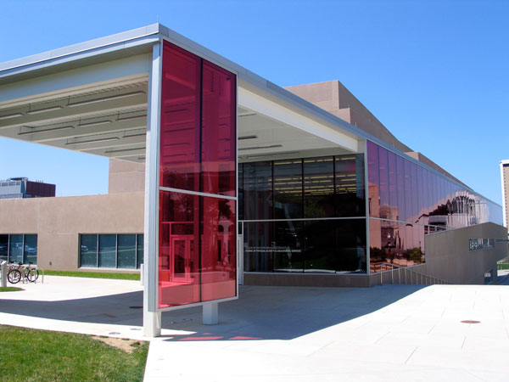 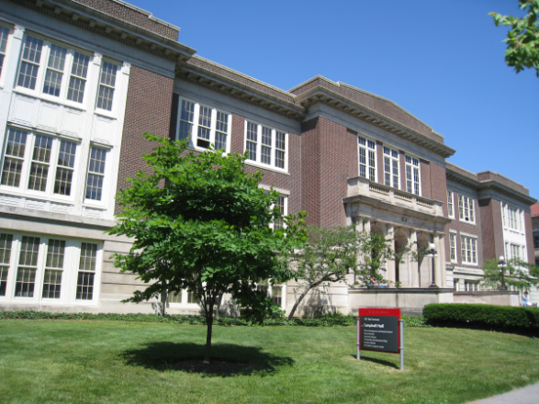

**Campbell Hall**

**PAES Building**



**Schoenbaum Family Center**

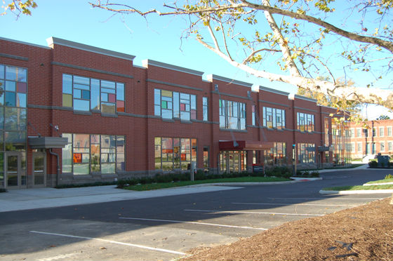

**Ramseyer Hall**

**CETE**

**Dennis Learning Center**

**Inside The Younkin Success Center**

In the College of Education and Human Ecology (EHE), our goal is to ensure that every new team member feels valued, equipped, and empowered to succeed in their role. This includes providing clear onboarding processes, access to resources, mentorship opportunities, and a culture that encourages collaboration, respect, and continuous learning.

By investing in the success of our new colleagues, we strengthen our teams and create a workplace where everyone can thrive.

**What to expect after accepting your EHE grad student position:**

|  |  |  |  |
| --- | --- | --- | --- |
| **Pre-Arrival** | **Name & Title** | **Schedule and Date** | **Completed “X”** |
| |  |  |  |  | | --- | --- | --- | --- | | **Workday Onboarding Setup** Is the completion of the Welcome Message that begins in your managers Workday to-do list to send to the you.  **Welcome to The Ohio State University!**   * New Employee Onboarding Guide to support a successful onboarding experience. [**https://hr.osu.edu/new-employees/**](https://hr.osu.edu/new-employees/)(select new student employees) |  |  |  | | **New Hire Manager** | **Once hire process is completed in Workday** |  |
| **To prepare new grad student employee for the first day –** The manager should work with the hiring unit to prepare the below as applicable and communicate it promptly to the new grad student employee.   * Office Space Assignment if not remote * Order Keys (Office and Building) * Confirm and Verify Computer and Printer Preferences * Office Set-up (Include Office Supplies) * Assign Mailbox and Copy Codes (If applicable) * Inform employee how they can access office supplies as needed for their position, such as if a GTA needs to print worksheets for a class they are teaching. * Manage Access: Make sure new employee has necessary access in order to perform duties, such as Teams Files, list serves, software, etc. (Note: GA Manager adds students to grad employee list serv, newsletter, and Teams.) | **Manager** |  |  |
| **Obtain Buck ID (if new student) and Parking Permit** (Items that you will need to obtain/complete please click on the below weblinks.)   * [Buck ID](https://buckid.osu.edu/): BuckID is the official OSU ID, providing access to Rec Sports facilities, Columbus area transportation, as well as serving as a debit card at many locations on and off campus. * [Parking Permit](https://osu.campusparc.com/home): GAs, Fellows, and Graduate Trainees are eligible to purchase either a “B” (staff) parking permit or a “C” (student) parking permit. Visit [Campus Parc's website](http://osu.campusparc.com/) to order a parking pass. Your funding letter can be used as proof of position to purchase a "B" (staff) parking pass. If you run into any issues with proof of position, please contact the Graduate Associate Manager, Amanda Crall ([crall.25@osu.edu](mailto:crall.25@osu.edu)). | **New Employee** |  |  |
| **Upon Arrival** | **Name and Title** | **Scheduled and Date** | **Completed “X”** |
| **Manager**   * Tour Facilities * Introductions to Peer Colleagues * [EHE Core Values](https://ehe.osu.edu/about/) * [College Leadership](https://ehe.osu.edu/about/leadership) * [EHE Pillars](https://ehe.osu.edu/about/pillars-college) * Organizational Chart * Role, responsibilities, goals, and expectations * Expected work schedule, work location, communication preferences, establish regular check-in/coaching meetings, etc. * [Review Graduate Associateship Guidelines](https://ehe.osu.edu/node/15902) * [GA Leave of Absence](https://ehe.osu.edu/financial-aid/graduate-associateships/absences) procedures (if applicable) * [EHE Graduate Student Travel Award Program](https://ehe.osu.edu/ehe-graduate-student-travel-award-program) opportunities to support professional development | **Manager Information** | **Date of Hire** |  |
| **Performance Management**  Review the [[Performance Management Process](https://portal.ehe.osu.edu/office-human-resources/performance)](https://portal.ehe.osu.edu/office-human-resources/performance) for your unit if applicable.  **Flexible Work Agreements (FWA) - If working remotely and/or a hybrid schedule or flexible schedule, you and your manager will need to complete the FWA using the date of hire and the end date of your appointment as listed on the funding letter.**   * Payroll withholds taxes based on the employee’s physical work location information provided in completed Flexible Work Agreements for telework (Remote or Hybrid) * The university is responsible for accurately withholding your state and/or local income tax based on your actual work location(s). It is your responsibility to ensure your work location(s) on record is accurate and up to date. * All faculty and staff working remotely in any capacity must continue to complete a Flexible Work Agreement and submit any changes as they occur. * If you are working fully remote or have a hybrid arrangement, working remote and on campus, report your work location(s) by completing the online [Flexible Work Agreement](https://hr.osu.edu/policies/flexible-work/)in HR Connection**.** * Once the FWA is submitted by the employee, it will route to the manager for approval. FWA submissions can be reviewed and approved through HRConnection. | **Manager Information** | **Within 30 Days** |  |
| **Systems Trainings and Access –** In order to gain full access to the OSU systems there are required trainings that must be completed in [BuckeyeLearn](https://u.osu.edu/buckeyelearn/) . Please review with your supervisor which may be required for your position.   * + ***Institutional Data Policy (IDP)*** – This course will describe your OSU role and responsibilities in preserving security and confidentiality while sharing and storing information. This training must be completed to gain access to OSU Systems.   + ***Report=Support! Identifying and Responding to Sexual Misconduct*** – How to identify, disrupt and report sexual misconduct. Must be Completed each year in order to be eligible for Annual Merit Increase.   + **Family Educational Rights & Privacy Act of 1974 (FERPA) –** Afederal law regarding the privacy of student records and the obligations of the institution, primarily in the areas of release of records and the access provided to these records. GTAs should complete this training as you interact with information that is considered part of the student's education record, such as grades, exam scores and GPA, and you may receive requests for the information (i.e. letters of recommendation, student performance from a parent or faculty member). In order for you to be prepared, confident, and responsible with the information you have access to and requests you receive, we would like you to complete the online FERPA training.   + The [Administrative Resource Center](https://admin.resources.osu.edu/) provides guides, job aids, training and more for current users of Ohio State's IT administrative tools, such as Workday, Buckeye Link, and Microsoft products.   + The [EHE faculty and staff portal](https://portal.ehe.osu.edu/) is the informational hub for the college - where you can find office sites and your contacts for services, where you can submit tickets for marketing and communications and IT support, and resources to support your important work here at EHE. GAs have access to this portal as well. | **New Employee** |  |  |
| **Resources**   * **GA Manager:** Amanda Crall, [crall.25@osu.edu](mailto:crall.25@osu.edu) * [GA website:](https://ehe.osu.edu/financial-aid/graduate-associateships/registration-requirements) eligibility and enrollment requirements, etc. * [HRconnection.osu.edu](https://hrconnection.osu.edu/esc) is used for general HR questions * <https://workday.osu.edu> is used to check appointment and pay information * [Office of Human Resources website](https://hr.osu.edu/benefits/student-employee/faqs/) can be a great resource for explanations of benefits * EHE GAs, Fellows, and Trainees Team site – contains announcements, important preparation information, and a way to chat with colleagues. * [Academic Calendar](https://registrar.osu.edu/academic-calendar/) * [OSU Graduate School Handbook](https://gradsch.osu.edu/graduate-school-handbook-gsh) * [Office of International Affairs (OIA)](https://oia.osu.edu/) * Carmen Resources: The [ODEE Resource Center](http://resourcecenter.odee.osu.edu/carmencanvas) provides a wealth of materials and videos on using Carmen (Canvas), workshops to enhance teaching skills, and online course support. * [Research Commons:](https://library.osu.edu/researchcommons/) Hosts events, workshops, presentations, and seminars offered throughout the year on a variety of research related topics, such as planning research, grant writing, IRB submissions, and publishing. * [Michael V. Drake Institute for Teaching and Learning (UITL):](https://drakeinstitute.osu.edu/workshops-and-events) Hosts workshops, seminars, events, and trainings on a variety of topics throughout the semester to enhance your teaching skills. I recommend looking through their calendar of events and adding some to your schedule. You do not need to have a teaching assignment to participate. These are great resume builders too! * Payroll schedule on the [Payroll Services website](https://busfin.osu.edu/buy-schedule-travel/payroll/paydate-schedule) * [Campus Map](https://maps.osu.edu/) * Get to know the city of [Columbus](https://www.columbus.gov/Home) | **New Employee** | **Review Materials** |  |