Highlighting health and Wellness Initiatives in EHE
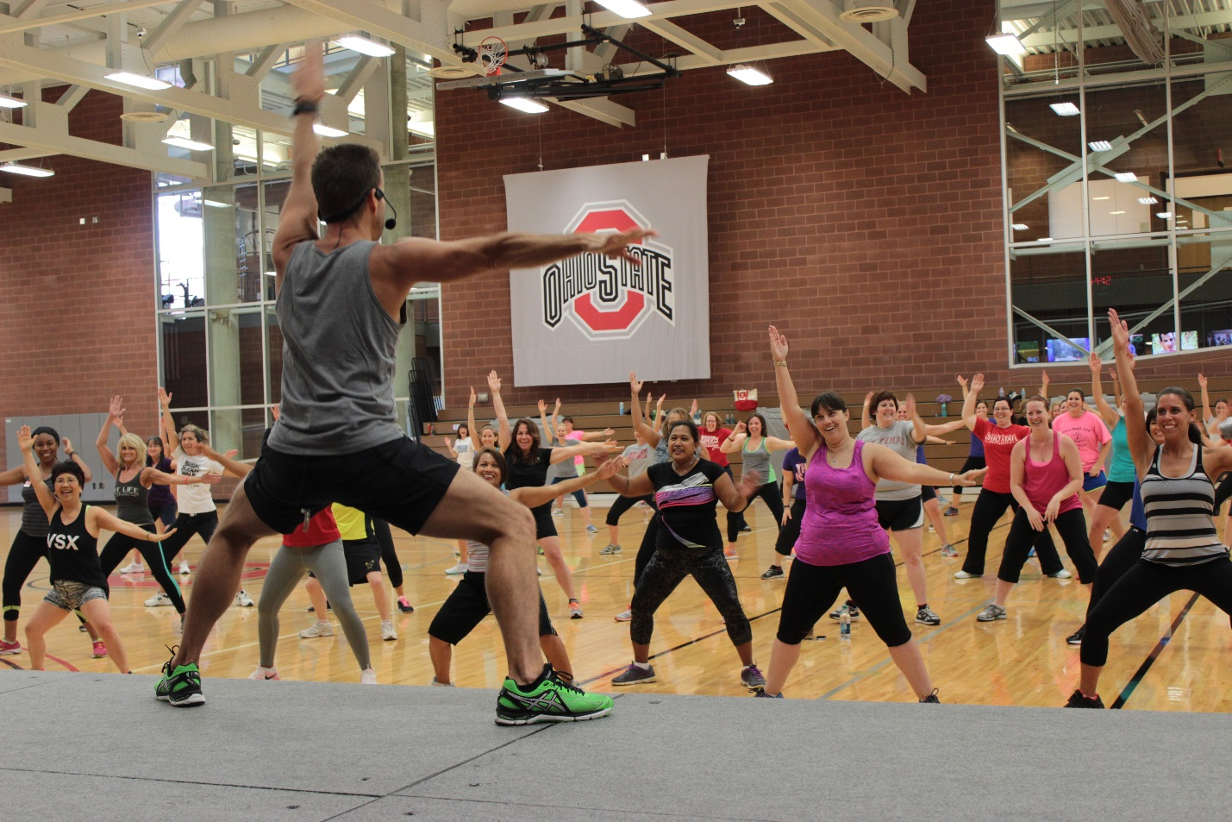Faculty from EHE have received external funding to conduct and create health and wellness-related research, services and training programs. Topics range from creating nutrition education and cooking programs to combatting childhood obesity to suicide prevention. More than $4M has been awarded to the college for the following 12 research awards. The following awards are currently active or were active within the past three months.
Skill-based RCT for physical activity using peer mentors
Rick Petosa, Human Sciences
As featured in our cover story, p.1
Purpose: train peer mentors to deliver culturally appropriate intervention and provide the social support that is critical for facilitating and sustaining health behavior change. The long-term goal of this study is to positively impact physical activity patterns to improve health outcomes, including the high rates of obesity in Appalachian teens.
Suicide prevention among substance abusing homeless youth
Natasha Slesnick, Human Sciences
Purpose: pilot test an intervention that has demonstrated feasibility and promise with adolescent suicide attempters. One-hundred fifty homeless youth with recent severe suicide ideation will be randomly assigned to the experimental cognitive therapy for suicide prevention in addition to services normally offered through a local drop-in center.
Evaluation of maternal, infant and early childhood home visiting program prenatal curriculum
David Julian, CETE
Purpose: provide the opportunity to add to knowledge and practices regarding interventions aimed at improving health outcomes for Ohio mothers and their children. Evaluators have designed a formal, state-of-the-art evaluation study to gain insight into the impact of an online training program called “InJoy Understanding Birth eClass.” Evidence has suggested that home visiting programs are powerful tools to address health disparities and other issues impacting pregnant women in Ohio.
Simple suppers scale-up: A nutrition education and cooking program delivered in the daycare setting designed to improve diet quality and weight status in preschool aged children
Carolyn Gunther, Human Sciences
Purpose: test a weekly hands-on program that combines nutrition education with skill building in cooking/food preparation for children and their parents, delivered over 3 months. Sessions will include nutrition education, cooking, family meal preparation, group meal, take-home educational materials, homework and session evaluation. This study can be expected to have a significant positive impact by providing a prototype for early establishment of healthy behaviors that leads to long-term benefits in promoting a lifestyle of healthy eating.
Training competitive nutrition scientists from underrepresented backgrounds in 21st century skills to stem the tide of childhood obesity
Carolyn Gunther, Human Sciences
Purpose: recruit four minority Scholars to the OSU undergraduate Human Nutrition program, nurture their academic development via intensive mentoring, research and outreach experiences, and provide enrichment activities. This program will enhance the competitiveness of students for admission and success in post-baccalaureate professional and graduate programs.
Development of effective behavior based standard operating procedures for fresh cut leafy greens in retail foodservice operations
Soobin Seo, Human Sciences
Purpose: develop a behavior-based food safety training program and standard operating procedures for the proper handling of fresh and fresh cut produce that can be implemented in all types of foodservice operations. This program also addresses consumer expectations and helps reduce the incidence of foodservice-originated_foodborne illnesses associated with fresh and fresh cut produce in the US.
Child and adult care food program (CACFP)
Laura Justice, CCEC
Purpose: provide aid to child and adult care institutions and family or group day care homes for the provision of nutritious foods that contribute to the wellness, healthy growth and development of young children, and the health and wellness of older adults and chronically impaired disabled persons.
Cognitive and physical benefits of AdvoCare Spark energy supplement
Jeff Volek, Human Sciences
Purpose: examine the effects of Spark on an array of cognitive functions, physical performance and mood in men and women. The study will also examine localized and global changes in brain activity before and during cognitive and physical tests.
Effects of GinST-15 on performance, stress, and neurophysiology in humans
William Kraemer, Human Sciences
Purpose: investigate the effects of GinST-15 on several increasingly well-recognized areas of potential benefit in humans: metabolism, physical performance, adaptation, recovery and related brain functions. The study will examine the effects of two weeks of supplement ingestion on various aspects of physical performance, recovery, biological activity, neurophysiological activity and perceptual/cognitive performance.
Effects of H9 hydrogen rich structured water on cognitive and physical performance in humans
William Kraemer, Human Sciences
Purpose: assess whether consuming hydrogen-rich water before, during and after a heavy resistance training protocol can demonstrate antioxidant effects leading to a reduction in skeletal muscle damage and fatigue. The study will also explore whether hydrogen-rich water can reduce cognitive and physical performance decrements after acute repetitive springs and heavy resistance exercise.
The Evaluation of a lifestyle intervention for employees with prediabetes
Carla Miller, Human Sciences
Purpose: enable the investigators to refine recruitment strategies and intervention procedures to develop a potentially sustainable university-based program for employees with prediabetes for a larger translational clinical trial. Participants will be randomly assigned to either a 16-week, group-based, lifestyle intervention delivered at the worksite or to usual care. The 16-week group-based intervention, adapted from the Diabetes Prevention Program, emphasizes reduction in dietary fat and energy intake and at least 150 minutes/week of moderate physical activity.
An integrated approach to enhance the microbial safety of fresh-cut fruit and vegetable products during processing, packaging, and retail distribution
Robert Scharff, Human Sciences
Purpose: enhance the microbial safety and quality of ready-to-eat, fresh-cut produce via integrated research and outreach/training targeted at the processing, packaging and retail distribution segments of the produce chain. The study will serve to enhance the safety and quality of fresh-cut fruits and vegetables and reduce the number of produce-related outbreaks.  
If you are interested in additional information about any of these projects, please contact the principal investigator (listed in red after the project title).

